Date / place:
Company name:
Responsible person Contact/data: | Name  Direct phone number  E-mail address
Other E-mail addresses to CC:

 | IGLO - LINE - automatic extruding and hardening tunnel
 | BASIC DATA
1. | Required capacity: | pieces/hour or cycles/minute

2. | MAIN PRODUCT DEFINITION:
2.1 |  | stick ice cream (“magnum” type) - volume ml | 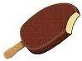
2.2 |  | stick ice cream (“funny face” type) - volume ml |   
2.3 |  | ball-top cone - volume  ml
2.4 |  | GIANT type cone – no chocolate coating - volume ml | 
2.5 |  | “twister” type horizontally extruded - volume  ml | 
2.6 |  | “mini-vienetta” type horizontally extruded – volume ml | 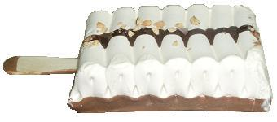
2.7 |  | sandwich standard  - volume ml | 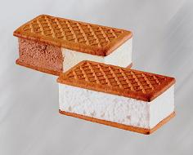
2.8 |  | Round sandwich  - volume ml | 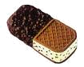  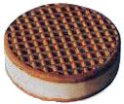
2.9 |  | sandwich half biscuit, half choco-coated  - volume ml
2.10 |  | candy bar - volume ml | 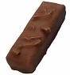
2.11 |  | bon-bon candy  - volume ml | 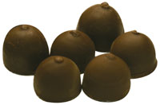
2.12 |  | layer cake - volume  ml  description | 
2.13 |  | standard 3-color log - volume ml | 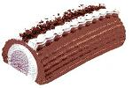
2.14 |  | other  (e.g. products hardened on the tunnel, but filled manually or on other machines)

3. | MACHINE TECHNICAL DETAILS AND REQUIREMENTS
3.1 | Evaporator (high efficiency air cooler): | required number of working hours without the necessity  of Iglo Line defrosting  standard execution (mix of construction materials)  stainless steel execution  special construction with different distances between fins to enable longer work without defrost  dehumidifier  cooling system consisting of three evaporators  other
3.2 | Cooling agent: | ammonia (NH₃)  freon, specify type:  other  Complete refrigeration unit or freon compressors?  Complete assembly of the refrigeration unit by ICE GROUP?
3.3 | Insulated chamber: | Insulated polyurethane panels :  standard – galvanized steel, white painted on the inside and on the outside  stainless steel on the inside and galvanized steel, white painted on the outside  stainless steel on the inside and on the outside  Inner part of hardening chamber:  standard execution chamber (panels riveted, floor welded)  fully welded stainless steel chamber inside
3.4 | Electronic and steering components: | Allen Bradley model/ size  Siemens model/size  B&R (Bernecker & Reiner) model/ size  Additional control box with 10” touch screen panel beside  DIP tower  Additional control box with 10” touch screen panel near  Multiline machine  other
 | Construction details, solution and components: | Gears and motoreducers:  basic, standard execution (e.g. Bonfiglioli, Motovario)  special, higher class execution (e.g. SEW, NORD)  other
Servomotors:
standard version
food-grade, white painted version
other
AC motors:
standard AB Motoren
SEW
other
Frequency inverters:
standard OMRON, MITSUBISHI ,RA, Bosch
Siemens
DANFOSS
other
Pneumatic components:
FESTO
SMC
other
 | Auxiliary accessories: | chocolate melting and preparation tank capacity  Liters  fruit / ingredient feeder  sauce pumps / chocolate pumps  Upgrade to chocolate pump to work with chocolate  with nuts (Lobe type)  Divided chocolate tank in DIP station to work with two  different chocolate colors (with additional second  chocolate pump)  300l chocolate buffer tank with pump (standard pump)  Crumbles constant feeder with conveyor for nuts

Continuous freezers (in your possession) to be connected to IGLO LINE
Manufacturer:
Capacity:
Remarks: | (e.g. automatic, manually operated, others)

